

Invoice Tracking Users

Process Flows

LOGIS Process
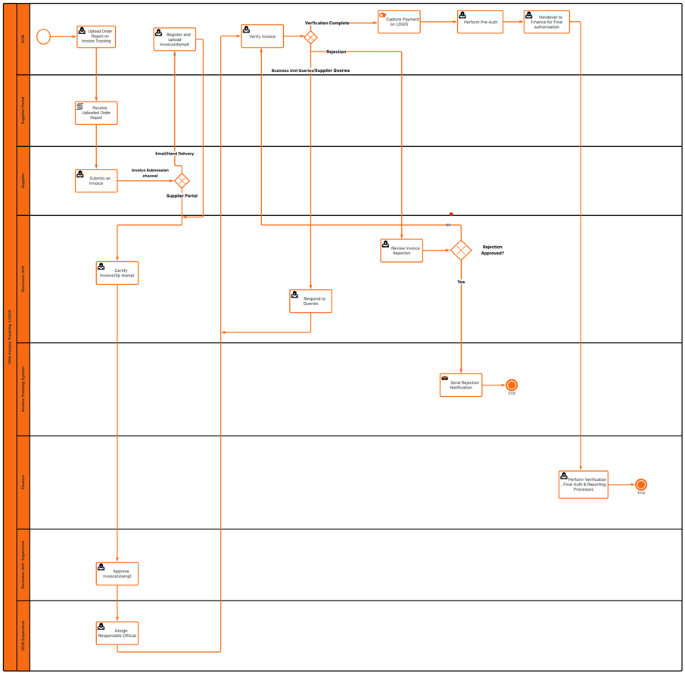

BAS Process
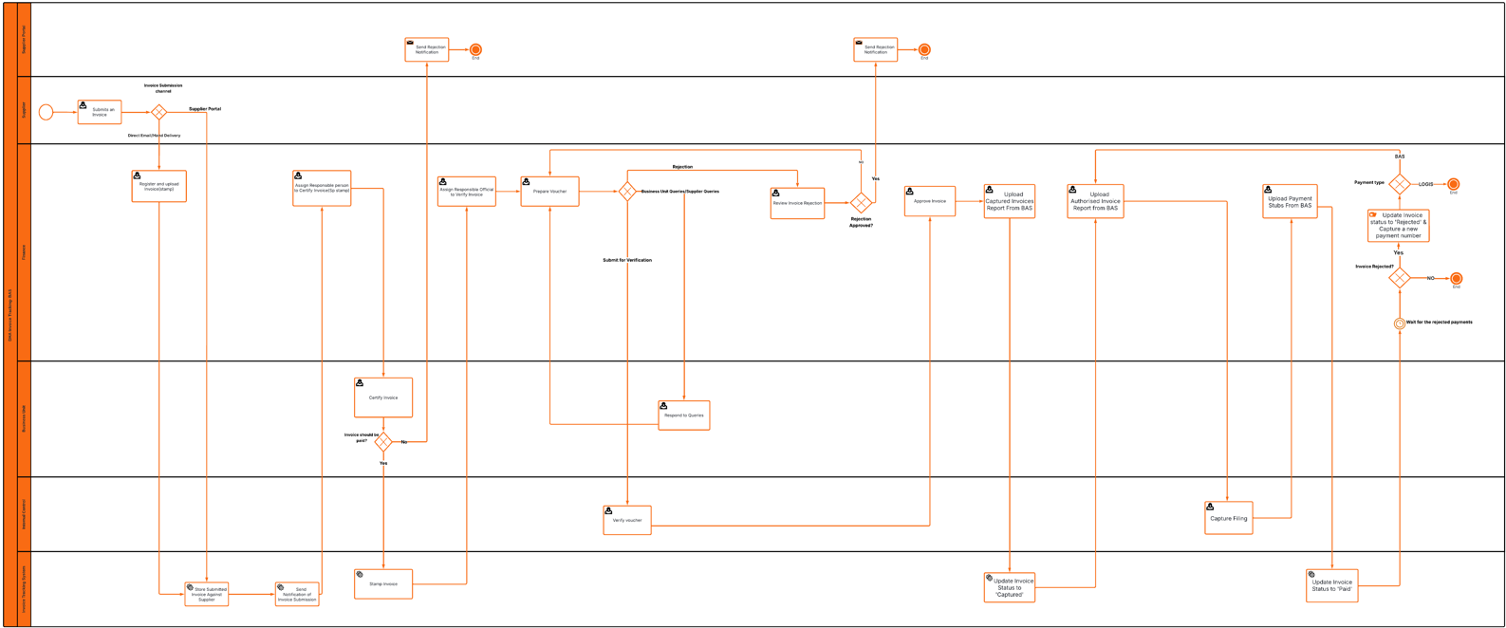

Suppliers

Supplier Name | Username | Password
GEMINI MOON TRADING 7 | Thulile.Matekanya@boxfusion.io | 123qwe

LOGI Process Users
Step Name | Assignee | Username | Password
Register and Upload Invoice | SCM | Moshadim | 123qwe
Certify Invoice | Business Unit | TaniaSmith | 123qwe
Re-route to Correct Business Unit | SCM Supervisor | Eunicem | 123qwe
Approve Invoice | Business Unit Supervisor | Tiyih | 123qwe
1Assign Responsible Official | SCM Supervisor | Eunicem | 123qwe
Verify Invoice | Assigned Business Unit | TaniaSmith | 123qwe
Manage Supplier Related Queries | Business Unit | TaniaSmith | 123qwe
Review Invoice Rejection | Business Unit | TaniaSmith | 123qwe
Business Unit: Respond to Queries | Business Unit | TaniaSmith | 123qwe
Capture and Link Invoice on LOGIS | SCM | Moshadim | 123qwe
Pre-Authorise Payment | SCM | Moshadim | 123qwe
Verify Voucher | Internal Control | Gwenb | 123qwe
Approve Invoice | Finance Unit | Thulilem | 123qwe
Final Authorise Payment | Finance Unit | Thulilem | 123qwe
Capture Filling | Internal Control | Gwenb | 123qwe
Attach Payment Stub | Finance Unit | Thulilem | 123qwe

BAS Process User

Step Name | Assignee | Username | Password
Register and Upload Invoice | Finance Unit | Thulilem | 123qwe
Assign Responsible Person to Certify Invoice | Finance Unit | Thulilem | 123qwe
Certify Invoice | Business Unit | TaniaSmith | 123qwe
Assign Responsible Person to Verify Invoice | Finance Unit | Thulilem | 123qwe
Prepare Voucher | Finance Unit | Thulilem | 123qwe
Manage Supplier Related Queries | Business Unit | TaniaSmith | 123qwe
Business Unit: Respond to Queries | Business Unit | TaniaSmith | 123qwe
Review Rejected Invoice | Finance Unit | Thulilem | 123qwe
Verify Voucher | Internal Control | Gwenb | 123qwe
Approve Invoice | Finance Unit | Thulilem | 123qwe
Upload Captured Invoices Report From BAS | Finance Unit | Thulilem | 123qwe
Upload the Final Authorised Invoices Report From BAS | Finance Unit | Thulilem | 123qwe
Capture Filling | Internal Control | Gwenb | 123qwe
Attach Payment Stub | Finance Unit | Thulilem | 123qwe

